- Learn to handling the Chrome Alerts
- Disable the data breach password leak detection alert
- Disable Chrome from offering to save passwords
- Disable the password manager overall
- Add the preferences map to ChromeOptions
- Initialize the ChromeDriver with the configured options

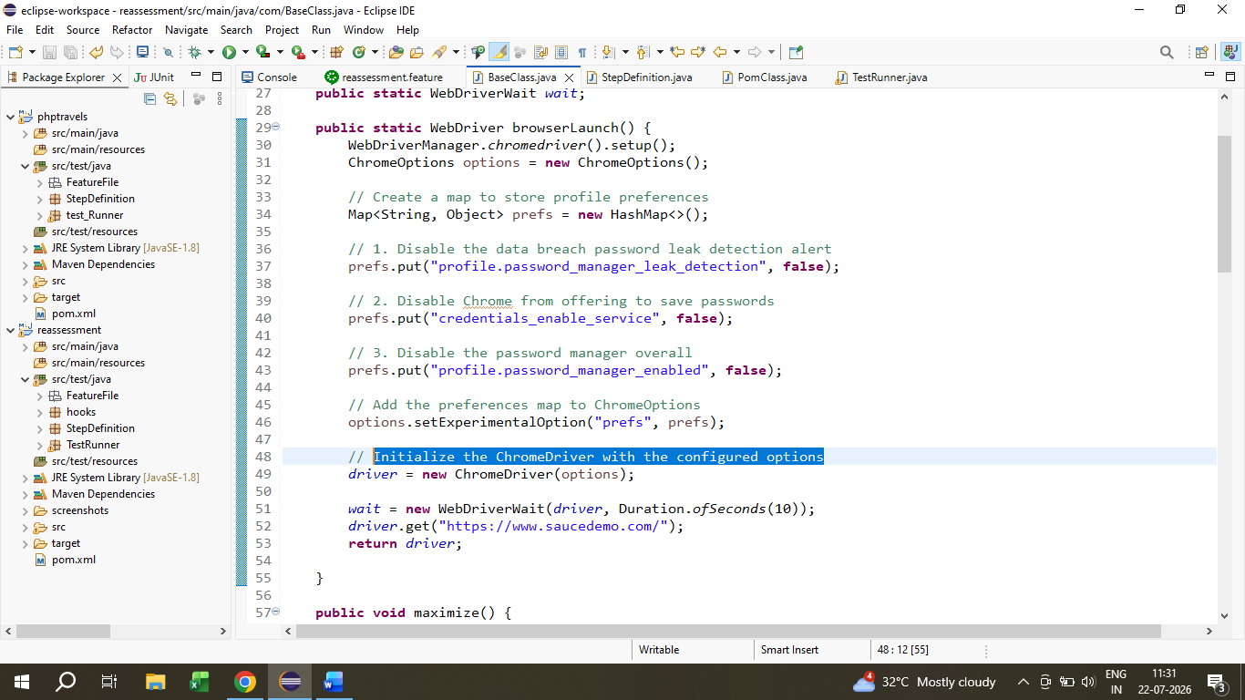

- Learning Screenshots method in Cucumber method
Adding Screenshot method in the base class and create a separate package in project setup to add screenshot after the failed tests

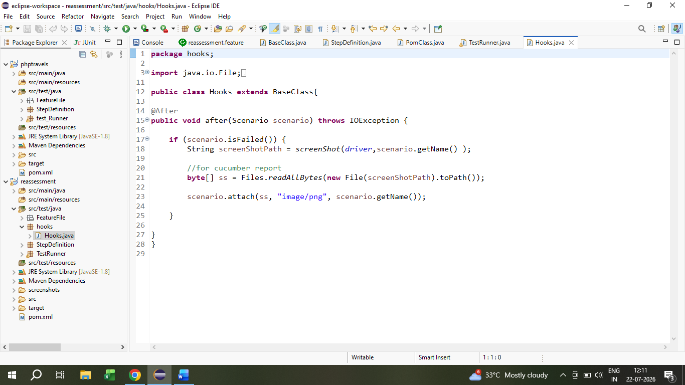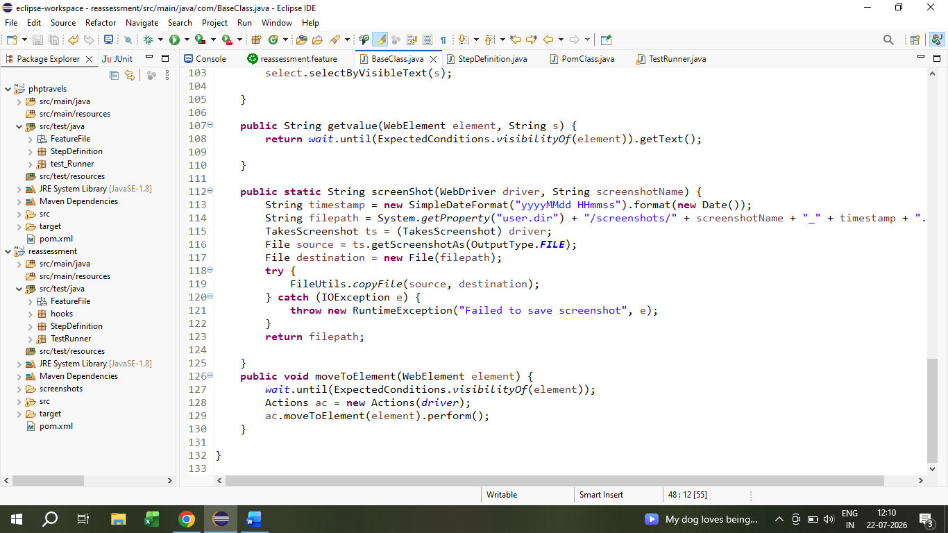

And Using this updated method , Practiced in the different demo websites.

